**COMP3005 A2 – Part 1**

**Problem 1**

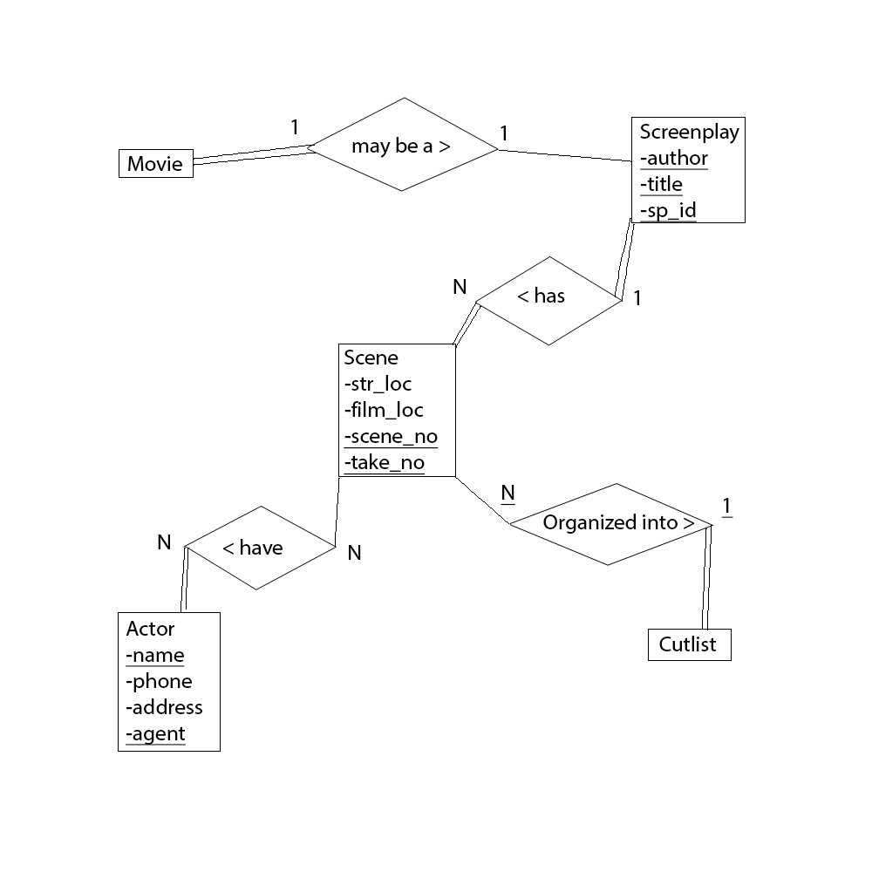

|  |  |  |
| --- | --- | --- |
| **Movie** |  |  |
| title | year | movie_id |

|  |  |  |
| --- | --- | --- |
| **Screenplay** |  |  |
| title | author | sp_id |

|  |  |  |  |  |
| --- | --- | --- | --- | --- |
| **Scene** |  |  |  |  |
| story_loc | film_loc | scene_no | take_no | movie_id |

|  |  |  |  |
| --- | --- | --- | --- |
| **Actor** |  |  |  |
| name | phone | address | agent |

|  |  |
| --- | --- |
| **Acting_in** |  |
| actor_name | scene_no |

|  |  |
| --- | --- |
| **Cutlist** |  |
| scene_no | take_no |

**Problem 2**

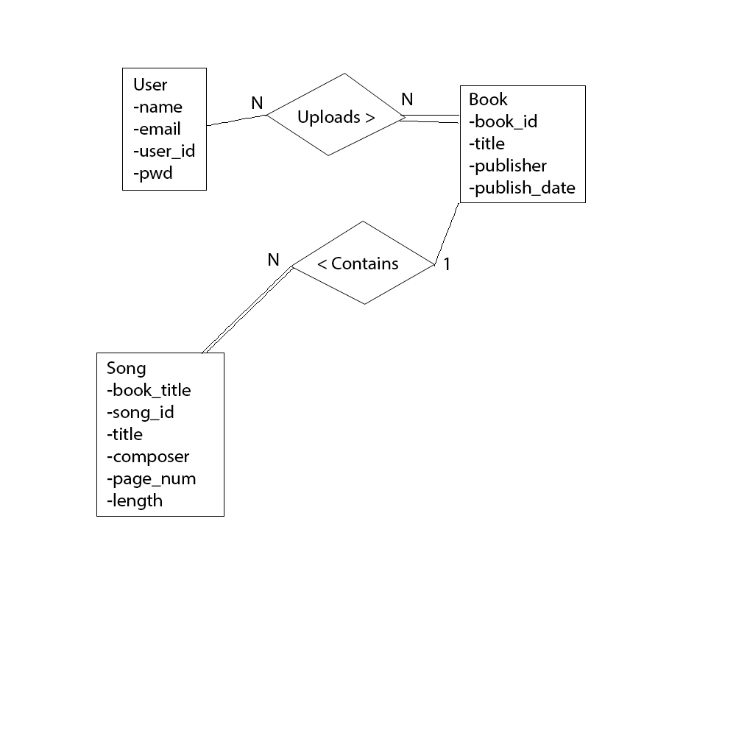

|  |  |  |  |
| --- | --- | --- | --- |
| **User** |  |  |  |
| name | email | password | user_id |

|  |  |  |  |
| --- | --- | --- | --- |
| **Book** |  |  |  |
| id | title | publisher | publish_date |

|  |  |  |  |  |  |
| --- | --- | --- | --- | --- | --- |
| **Song** |  |  |  |  |  |
| book_title | song_id | title | composer | page_num | length |

|  |  |
| --- | --- |
| **Has_access** |  |
| user_id | book_id |

**Problem 3**

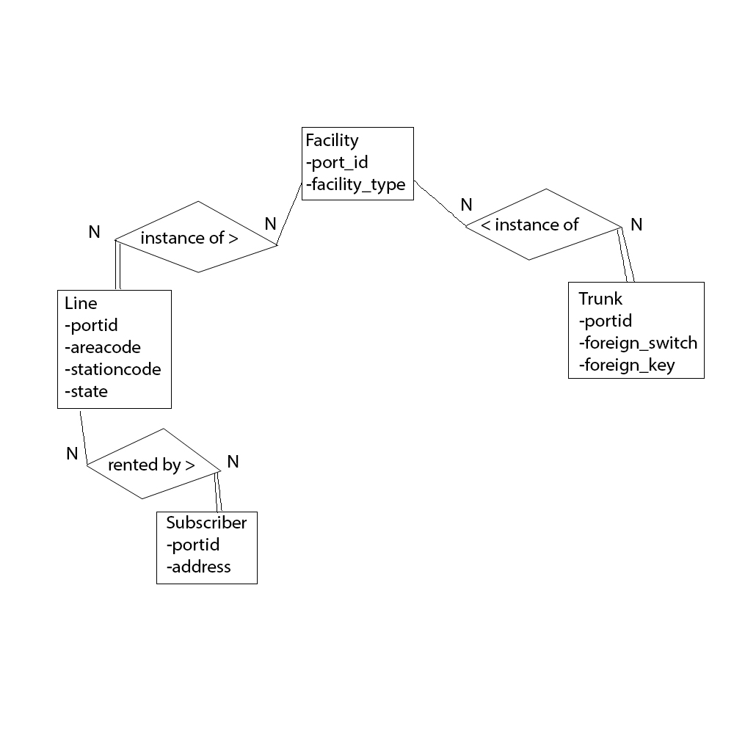

|  |  |
| --- | --- |
| **Facility** |  |
| portid | facility_type |

|  |  |  |  |  |
| --- | --- | --- | --- | --- |
| **Line** |  |  |  |  |
| portid | areacode | officecode | stationcode | state |

|  |  |
| --- | --- |
| **Trunk** |  |
| portid | foreign_switch |

|  |  |
| --- | --- |
| **Treatments** |  |
| tcode | portid |

|  |  |
| --- | --- |
| **Services** |  |
| scode | service |

|  |  |
| --- | --- |
| **Service_subscribers** |  |
| line | service |

|  |  |  |
| --- | --- | --- |
| **Subscribers** |  |  |
| portid | name | address |

|  |  |  |
| --- | --- | --- |
| **Trunk_channels** |  |  |
| portid | channel | state |

|  |  |  |  |  |  |  |  |
| --- | --- | --- | --- | --- | --- | --- | --- |
| **Calls** |  |  |  |  |  |  |  |
| call_id | orig | term | och | tch | area | office | stn |

|  |  |  |
| --- | --- | --- |
| **Trunk_routes** |  |  |
| portid | area | office |

**Problem 4**

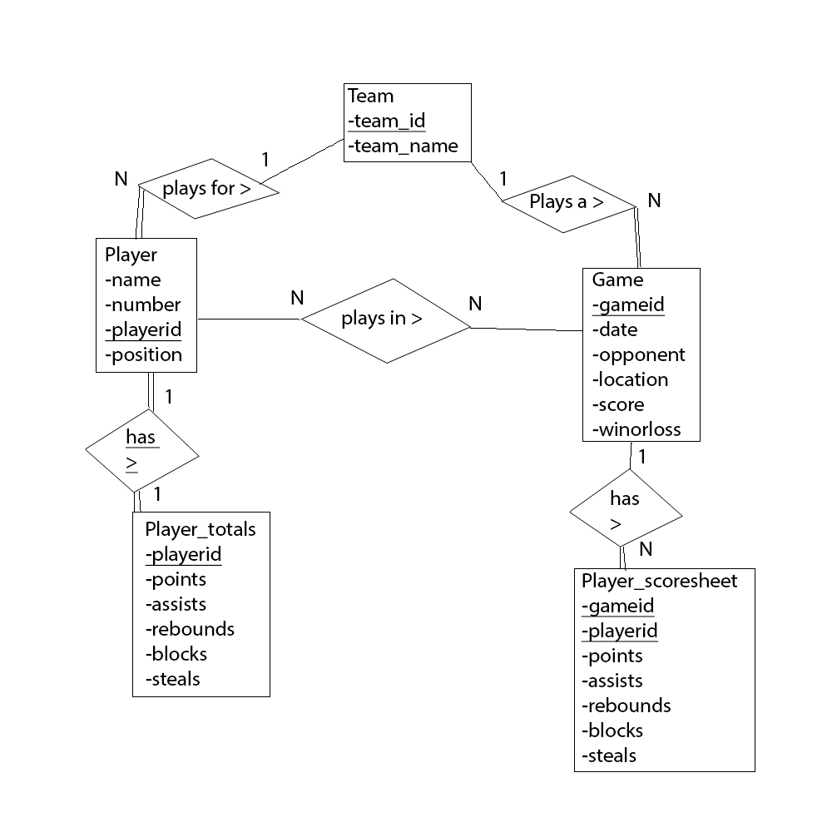

|  |  |
| --- | --- |
| **Team** |  |
| team_id | team_name |

|  |  |  |  |
| --- | --- | --- | --- |
| **Player** |  |  |  |
| name | number | player_id | position |

|  |  |  |  |  |  |
| --- | --- | --- | --- | --- | --- |
| **Game** |  |  |  |  |  |
| gameid | date | opponent | location | score | winorloss |

|  |  |  |  |  |  |
| --- | --- | --- | --- | --- | --- |
| **Player_totals** |  |  |  |  |  |
| playerid | points | assists | rebounds | blocks | steals |

|  |  |  |  |  |  |  |
| --- | --- | --- | --- | --- | --- | --- |
| **Player_scoresheet** |  |  |  |  |  |  |
| gameid | playerid | points | assists | rebounds | blocks | steals |

**Toronto Raptors Statbook**

**Background**

This project is motivated by my own personal interests in the Toronto Raptors basketball team. There are many websites that track the stats of basketball players, but I will be mainly focusing on the website called “basketball-reference”. Basketball reference contains a massive amount of information on every player in the NBA. Basketball reference not only contains the averages of players’ points, assists, rebounds, etc. over seasons, but also stores information for each individual game that a player participated in as well as the statistics of the entire team for that game.

**Application Requirements**

The following describe what is required from the application.

R1.1) Provide a database table that catalogues the games that a team has played, providing the information such as the date, the team that was played against, whether it was a home or away game, the score of the game, and who won the game.

R1.2) Provide a database table that contains rows for each Raptors player contain that players position, how many points, assists, rebounds, blocks, and steals that player had in a specific game, as well as how many minutes they played in that game.

R1.3) My application should allow users to ask for a player and have a table returned with the rows containing the stats from every game that player played this season.

R1.4) My application should allow users to ask for a player and have a row containing their average stats in points, assists, rebounds, blocks, and steals returned.

R1.5) My application should allow users to ask for a game and have a table returned with the stats of each player that played in that game.

R1.6) The target size of the database would be 82 games, which would be how many games are played by a team in a regular NBA season, as well as up to 28 extra games for playoffs, depending on how many playoff games a team plays.

R1.7) The user should be able to ask for a player and have a row returned containing their average regular season stats subtracted from their average playoff stats in order to compare if a player over or underperformed in the playoffs, for example: -2.3 points, -0.4 assists, +1.7 rebounds, +0.8 blocks, +0.0 steals per game in the playoffs compared to the regular season.

R1.8) The user should be able to access this data through a web application built with a Django backend and a frontend built in some flavour of JavaScript such as jQuery or angularJS.

**Due Diligence (Copyright Issues)**

A quick Google search has revealed that while the actual NBA games are copyrighted, the statistics are facts which any person watching a game may obtain and facts are not copyrightable. Sports Reference LLC, the parent company of basketball-reference does contain a copyright “all rights reserved” at the bottom of their website.

CPY1.1) it is my belief that based on the notion that facts are not copyrightable and it is plausible that I could have simply watched each individual game and recorded the stats myself that it is not illegal for me to document these stats and store them in my database.

**Sample Documents**

Typical score sheet provided by nba.com

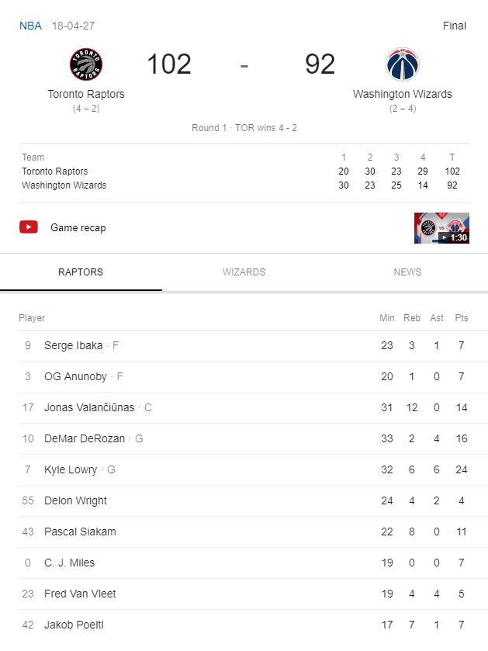 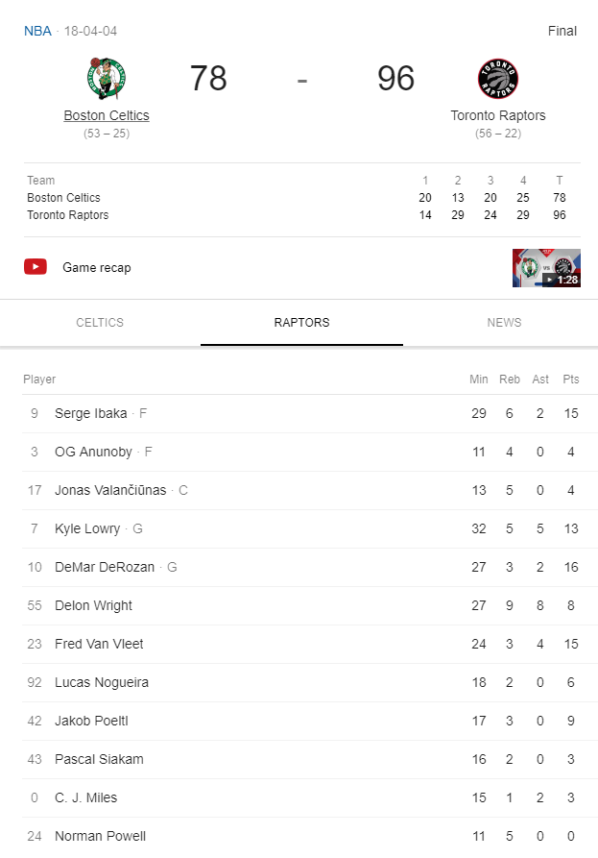

Typical individual player sheet provided by basketball-reference.com

